

**ADDIS ABABA UNIVERISITY**

**ADDIS ABABA INSTITUTE OF TECHNOLOGY**

**CENTER OF INFORMATION TECHNOLOGY AND SCIENTIFIC COMPUTING**

**DEPARTMENT OF SOFTWARE ENGINEERING**

**Ethiopian Music Service(Musika)**

Project Proposal

**PREPARED BY:** -

1. Eyosias Samson
2. Gemechu Mohammed
3. Henok Akanaw
4. Immanuel Alemtena
5. Kaleab Belete
6. Kalid Sultan

**ADVISOR**: Mr. Fitsum Alemu

**March 2018**

**ACKNOWLEDGMENT**

We would like to express our special gratitude to our project advisor Mr. Fitsum Alemu for his tireless efforts in helping us craft this project proposal from scratch. Despite our innumerable errors and shortcomings which he has gracefully tolerated, he has helped us become better thinkers and writers.

**TABLE OF CONTENTS**

ACRONYMS v

ABSTRACT vi

1. INTRODUCTION 1

1.1 Background of Musica 1

1.2 The Existing System 2

1.3 Statement of the Problem 2

1.4 Objective of the Project 3

1.4.1 General Objective 3

1.4.2 Specific Objective 3

1.5 Proposed System 3

1.6 Feasibility Study 4

1.6.1. Economic Feasibility 4

1.6.1.1. Developmental cost 4

1.6.1.2. Operational Cost 4

1.6.2. Technical Feasibility 5

1.6.3. Schedule Feasibility 5

1.7 Scope 5

1.8 Methodology 6

1.9 Project Management plan 7

1.9.1. Time Management plan 7

1.9.2. Quality Management Plan 8

1.9.3. Communication Management Plan 8

APPENDIX ix

REFERENCE x

# 

# **LIST OF TABLES**

Table 1 – Developmental Cost ix

Table 2 - Operational Cost x

Table 3 - Time Table Chart (Gant Chart) xii

Table 4 - Organizational Structure xiii

List of Figures

Figure 1 - Existing System viii

Figure 2 Existing System viii

# **ACRONYMS**

**CD**: Compact Disk

**EIPO**: Ethiopian Intellectual Protection Office

**CBE**: Commercial Bank of Ethiopia

# **ABSTRACT**

It’s not worth noting that Music is a fabric of our lives. It is the universal language that can trigger the feelings of happiness, nostalgia, or even sorrow by speaking to the soul. Not only does Music bring people together, it also brings us closer to ourselves and others in that it creates an avenue for empathy and understanding. Music is engraved into human society so much in that it is apparent in every significant event from weddings and funerals to graduation ceremonies, formal inaugurations and birthdays.

Now in the 21st century, Ethiopian music is gaining popularity and mixing with cultures around the world. Today’s artists like Teddy afro, Jackie Gossaye, Zeritu Kebede and Jano band are gaining popularity even outside of Ethiopia. An illustrative example is Teddy Afro’s new album which was ranked #1 on Billboard’s “World Music Charts” on 2017. [1] As these artists grow and become more famous around the world, their songs are getting more valuable in the market. Thus, creating a need for stronger methods of copyrighting their works.

# **INTRODUCTION**

## **Background**

Ethiopian music is a reflection of its historical and social episodes. Before the second world war, Ethiopia’s culture was influenced by Muslim countries around its port. Therefore, Ethiopian music before the war was religious and secular which traced back to Saint Yared during the reign of Gabra Masqal. [2] However, during the 20th century, Ethiopia became highly influenced by European culture and thus a whole new genre of Ethiopian music was born. Moved by a free-spirited society, this genre headed towards Rock and Roll and twisted without losing its roots. Swinging Addis, was very popular during the 1960s and 1970s with the azmari-bets in Addis Ababa. [3] This paved the way for prominent artists like Mahmoud Ahmed (The Ethiopian Elvis), Mulatu Astatke (king of Ethio-jazz) and Tilahun Gessesse (The Voice) to cease the opportunity and revolutionize the Ethiopian music forever. [4]

The fundamental idea behind establishing a copyright law is the encouragement of creativity and protection of an individual’s or a company’s right to ownership of a product. [5] The law gives the owner the exclusive right to sale, rent, transfer, communication and reproduction of the work to the public.

In Ethiopia, intellectual property copyright is a very recent development compared to that of the rest of the world. The origins of copyright protection date back to the Civil Code of 1960. It is the first law that deals with copyright issues in Ethiopia. It discusses about protection of Literary and artistic ownership. However, this code wasn’t good at thinking ahead. As time went by, the need for a specific law dealing with copyright became crucial. [6]

So, the Ethiopian Intellectual Property Office(EIPO) was established as an autonomous institution in 2003 to solve the problem. Soon after, the Copyright and Neighbouring Rights Protection Proclamation No.410/2004 was enacted in 2004. It introduced new rights for owners, widened the scope of copyright and related rights, and provided a better mechanism of enforcement and protection of copyright. [7]

However, a study conducted by Ethiopian Intellectual Property Office(EIPO) on the level of copyright infringement at a national level indicates that the infringement rate was 58.6% for the year 2014. Out of this, the infringement rate on musical works was 80.33% far higher than that of films, which was at 49.05%. This constant infringement of intellectual property rights in the music industry affirms that Ethiopia’s music sector is prone to piracy and corruption. [8]

## **The Existing System**

Currently like that of most developing countries, the music industry in Ethiopia uses some common way of distributing musical works to society. First the artist and the recording studio sign a contractual deal in order to proceed with the production of the album. This deal allows the artists to get involved in the production of their albums while the studio handles the distribution. To distribute the music, the studio uses various methods like Street to Street sellers, vehicle stand sellers and other studios. Mainly these music albums are distributed through Compact Disks (CDs) due to their cheapness and availability.

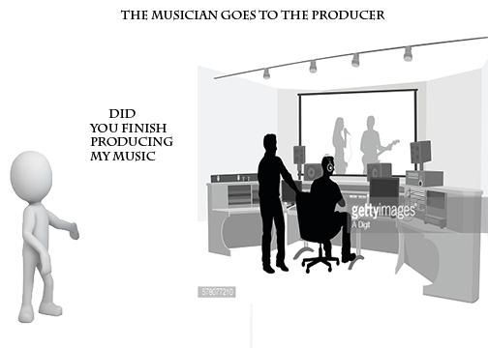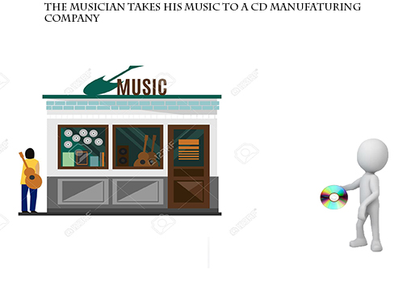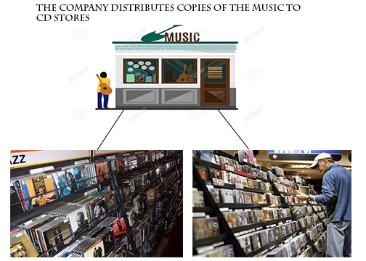

Figure 1 Existing System

## **Statement of the Problem**

One of the major problem that is observed on the current system is when artists produce a music album, the studio releases it through CDs. This mechanism allows customers to rip the files from the CDs to either copy the music to their phones and flash drives or upload it to a different site in the web. These customers will most likely then distribute the copyrighted music to their friends for free without any regard to the copyright laws. In consequence to that there will be a lots of damage intellectual property and also result in the loss of money.

## **Objective of the Project**

### **General Objective**

The main objective of this project is to develop a system that allows clients to purchase music products.

### **Specific Objectives**

In order to achieve the general objective, the following specific objectives must be attained:

* Perform a detail analysis on the current system
* Design and prototype a new model
* Receive feedback from beneficiaries and end-users
* Customize the prototype to suit their needs

## **Proposed System**

This project is intended to eliminate the above problems by letting users have a legal access to songs via their mobile phones. This allows consumers with the desire to possess digital music content without infringing the nation’s copyright laws to do so legitimately. This can be done as follows:

First the user downloads and installs the application on his/her mobile phone. Then he/she is required to setup his account by filling in his/her personal information. Upon doing so, the user will be provided with a list of songs currently available in the storage unit. To download a song, the user is asked to give his/her bank credential information. After the user provides his credentials the system tries to confirm their validity. Then the application will allow the user to download the music into the application. An important thing to note is that the system will not directly download the song into the mobile phone rather it would only be available offline for the customer.

**Feasibility Study**

## **Economic Feasibility**

### **Developmental cost**

Table 1 – Developmental Cost

|  |  |
| --- | --- |
| **Operation** | **Cost** |
| Employees | 0 br |
| Interviews | 200 br |
| Internet Research | 300 br |
| Food | 400 br |
| Transportation | 800 br |
| Other | 300 br |
| **Total** | **2000 br** |

### **Operational Cost**

Table 2 - Operational Cost

|  |  |
| --- | --- |
| **Operation** | **Cost** |
| Deployment | 0 br |
| Domain name | 1000 br |
| Web hosting | 500 br |
| **Total** | 1500 br |

## **Technical Feasibility**

Our team is proficient in the programming languages this system requires – namely Python and Java. We also have taken courses in Networking and data structures and algorithms. Although, we still have much to learn regarding encrypted data transfer and Graphics design, we believe we will acquire the necessary expertise soon enough to get the system completed in time.

## **Schedule Feasibility**

The system is scheduled to get delivered at the end of the semester. Even if there are several other projects that may hinder our progress, we intend to finish the project at the designated date by following the proper procedures.

**1.7 Scope**

This platform is aimed solely at providing a legal digital music marketplace for the Ethiopian people. Consumers that wish to abide by national copyright laws will be able to legally possess digital formats of their favorite songs. However, this proposed system does not take into account piracy that results from the desire to have a free access to intellectual property. This problem lies in the arena of digital law enforcement and thus not relevant to our proposal. This system is supposed to fulfill these features:

* Allow users to purchase music with Ethiopian currency.
* Allow artists to receive payment for their works.
* Create an ecosystem where both users and artists are both happy.
* By utilizing the new online payment systems developed by the Commercial Bank of Ethiopia, it will create a mobile application that allows for digital music purchases.

## **Methodology**

We have selected the Waterfall software development model because it satisfies the following requirements:

* Our project has rigid and well-defined requirements.
* The model is easy to manage due to its strict nature.
* The model works well for smaller projects like ours whereby significant changes post-development are unlikely.

## **Project Management plan**

## **Time Management plan**



Figure 1 Gantt Chart

1. **Quality Management Plan**

The quality assurance of this project focuses on the processes used in the manufacturing of the application. In order to assure quality, an iterative quality process will be used throughout the project life-cycle. This iterative process includes assessing and evaluating risk, repeated testing and continuous feedback gathering from users.

**1.9.2.1. Organization and Responsibilities**

Table 4 - Organizational Structure

|  |  |  |
| --- | --- | --- |
| **Name** | **Role** | **Quality Responsibility** |
| Kaleab Belete | Project Manager  Project Delivery Team | * Documenting customer expectations * Utilizing the expertise of the Project Delivery team to determine the necessary procedures. * Delivering a quality product |
| Kalid Sultan | Project Delivery Team | * Performing an active role in ensuring the customer’s quality objectives are clearly articulated and that the customer understands the professional standards, laws and codes which must be incorporated into the project. * Monitoring the quality of their work. * Keeping the commitment for the completion of their project |
| Eyosias Samson |
| Immanuel Alemtena |
| Gemechu Mohammed |
| Henok Akanaw |

**1.9.2.2. Quality Assurance**

The final system will be reviewed to ensure that the mobile application adheres to the following standards:

* It conforms to the application guidelines stipulated by Google’s play store
* It does not exhibit any errors or crash unexpectedly
* It does not exhibit any user interface glitches
* The user experience is consistent throughout the entire application.
* All graphical assets are aesthetically pleasant and catered to devices with high resolution
* It executes all financial transactions flawlessly and with complete accuracy

**1.9.2.3. Risk Management**

We will list and document the quality assurance to cross check with every product and for ensuring good quality.

Some examples of risk management approaches

* By using Git and Github to improve cooperation and reduce operational time costs.
* Requesting assistance from our adviser when we encounter concepts beyond our understanding.
* In the case of a nationwide internet ban following political unrest, we would use library archives to learns about subjects of interest and exchange project updates through flash drives.

1. **Communication Management Plan**

Table 5 Communication plan

| **Type of Communication** | **Method / Tool** | **Frequency/Schedule** | **Information** | **Participants / Responsible** |
| --- | --- | --- | --- | --- |
| **Internal Communication:** | | | | |
| Project Meetings | Telegram, Trello, physical meeting | Twice a week and on events | Project status, problems, risks, changed requirements | Project Mgr. Project Team |
| Sharing of project data | Git | When available | All project documentation and reports | Project mgr.  Project Team |
| Milestone Meetings | In face | Once a week | Project status (progress) | Project mgr. project Team. |
| Final Project Meeting | In face | Monday | Wrap-up Experiences | Project mgr. Project Team |

# 

# **APPENDIX**

**Album** - is a collection of audio recordings issued as a single item on CD, record, audio tape or on an online music streaming service.

**Application** - collection of Android mobile-based programs.

**Artist** - a person who plays a musical instrument or is musically talented.

**Available offline** - an encrypted download in which files can not be manipulated through a device’s file manager.

**Beneficiaries** -a person, organization named to receive benefits.

**Contractual deal** - a binding agreement between two or more persons or parties.

**Copyright** - legal right to be the only one to reproduce and sell musical recording.

**Current System** - CD based music distribution system.

**Customer** -One who purchases music using any platform.

**Data structure & Algorithm** - stream of software engineering that focuses on finding programmatic way of storing data so that data can be used efficiently. 

**Download** -to make a file available for download and accessible through a file manager.

**End users** -mobile application users

**Git** -is a free and open source distributed version control system designed to handle everything from small to very large projects with speed and efficiency.

**Git Hub** - the world's largest community of developers to discover, share, and build better software.

**Prototype** -is an early sample, model, or release of a product built to test a concept or process or to act as a thing to be replicated or learned from.

**Recording studio** -is a specialized facility for sound recording, mixing, and audio production of instrumental or vocal musical performances, spoken words, and other sounds

**Rip** -to pull or download music forcibly away from CDs by using software.

# **REFERENCE**

[1] Dire Tube , <https://www.diretube.com/teddy-afros-ethiopia-album-1-on-billboard-world-chart_b2e4af09b.html?fb_comment_id=1361306967292178_1362543803835161>, 07/03/2018

[2] FSU World Music Online, <http://fsuworldmusiconline.wikidot.com/historical-journey-of-ethiopian-music-origins>, 07/03/2018

[3] Music in Africa, <https://www.musicinafrica.net/magazine/birth-modern-ethiopian-music>, 07/03/2018

[4] Ethiopiques Music, <https://www.last.fm/tag/ethiopiques>, 07/03/2018

[5] Law Ethiopia, https://www.lawethiopia.com/images/federal_proclamation/proclamations_by_number/872.pdf, 07/03/2018

[6] Addis Standard , <http://addisstandard.com/copyright-protection-in-ethiopia-shining-law-zero-effect/> , 06/03/2018

[7], [8] Music in Africa , <https://www.musicinafrica.net/magazine/copyrights-royalties-and-music-piracy-ethiopia> , 06/03/2018